**Amazon AWS Notes**

**Identity and Access Management (IAM)**

Identity management is all about setting users and granting them access to the aws console.

IAM allows us to manage users and their level of access to the aws console.

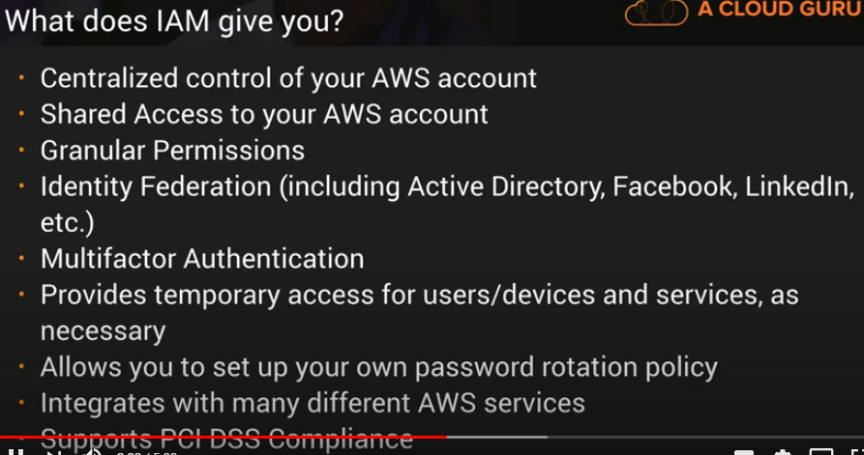

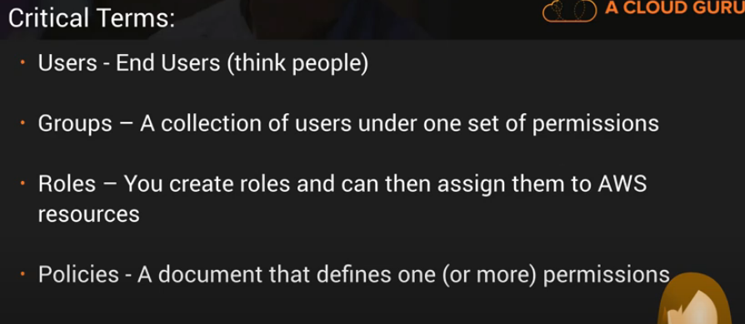

**S3**

Simple storage service

